A. Atomic structure: Model of the atom and structure of the atom
- What was the earliest model of the atom?
- Which subatomic particle did JJ. Thomson discover?
- Which early atomic model does the following diagram show?
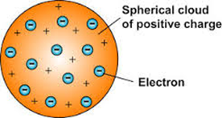
- Name Rutherford’s experiment.
- State two ways in which Rutherford’s experiment changed Thomson’s model of the atom.
- How did Bohr adapt the nuclear model?
- Explain why Bohr revised Rutherford’s model of the atom.
- Name three subatomic particles and their charges.
- Complete the sentence ‘All atoms of one type of element have the same number of…’

- What does the atomic number tell us about an atom?
- What does the mass number tell us about an atom?
- Why is the overall charge of an atom zero?
- Calculate how many protons, electrons and neutrons there are in a silver atom with atomic number 47 and mass number 108.

B. Atomic structure: Isotopes and relative atomic mass
- What is an isotope?

- Why do some elements have relative atomic masses which are not whole numbers?

- Calculate the number of neutrons in this isotope of chlorine.
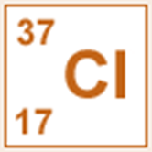
- (HT) Boron has two naturally occurring isotopes B-10 (20%) and B-11 (80%). Calculate the relative atomic mass of bromine.

- (HT) Magnesium has three naturally occurring isotopes Mg -24 (79%); Mg – 25 (10%) and Mg – 26 (11%). Calculate the relative atomic mass of magnesium.

C. Periodic table: Mendeleev, atomic number, metals and non-metals and electronic configuration
- How are elements arranged in the periodic table?
- What are the columns of the periodic table called?
- What are the rows of a periodic table called?
- What does the column an element is in tell you about the atoms?
- What does the row an element is in tell you about the atoms?
- Which side of the periodic table are the non-metals found?
- How did Mendeleev arrange the elements in his periodic table?
- How did Mendeleev use his periodic table to predict the existence of some elements not then discovered?

- Why is the order based on atomic masses not always correct?
- What do we call elements that tend to form positive ions?
- What is the electron configuration for sodium?
- Draw the electron configuration for a chlorine atom.
- Write the electron configuration for potassium.
D. Ionic bonding
- What is a cation?
- What is an anion?
- What types of substances bond together with an ionic bond?
- What happens to the electrons in ionic bonding?
- What electronic structure do the ions produced by metals in Groups 1 and 2 and the non-metals in Groups 6 and 7 have?

- What is the link between the charge number on the ions in Groups 1, and 2 and their group?

- What is an ionic compound?
- How are ionic compounds held together?
- Draw a diagram to show how potassium and chlorine atoms join together to form ions.

- Explain how you can use the following model to work out the empirical formula of sodium chloride.

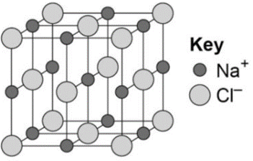
- What does it mean if a compound ends in –ide?
- What does it mean if a compound ends in –ate?
- Calculate how many protons, electrons and neutrons there are in
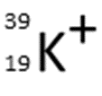

E. Covalent bonding
- How are strong covalent bonds formed?
- What is formed by covalent bonding?
- What is the formula of the following model?
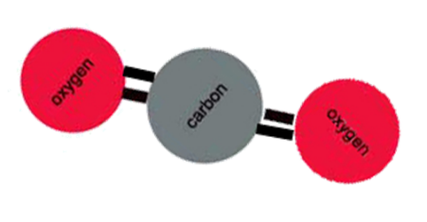
- What is the typical size of an atom?
- Draw a dot and cross diagram for water.
- Draw a dot and cross diagram for an oxygen molecule.
F. Properties of substances: ionic substances, simple molecular compounds (covalent)
- Describe the structure of ionic compounds.
- Why do ionic compounds have high melting and boiling points?
- Why can ionic compounds conduct electricity when melted or dissolved in water?
- What state of matter are small molecules normally found in?
- Why do small molecules have low melting and boiling points?
- What happens to the melting and boiling points as small molecules get bigger? Why?
- Why don’t small molecules conduct electricity?

G. Properties of substances: Diamond, graphite, graphene, fullerenes and polymers
- In a diamond, how many covalent bonds does each carbon make?
- Diamond does not conduct electricity. Why?
- Name 2 other properties of diamond.
- In graphite, how many covalent bonds does each carbon make?
- Describe the structure of graphite.
- Why is graphite soft?
- Why does graphite conduct electricity?
- How is graphite similar to metals?
- What is graphene?
- What are fullerenes?
- What was the first fullerene to be discovered?
- What are carbon nanotubes?
- What are carbon nanotubes useful for?
H. Properties of substances: Metals and the limitations of models
- Why do most metals have high melting and boiling points?
- How are atoms arranged in pure metals?
- Why are metals good conductors of electricity?
- What is thermal energy?
- Why are metals good conductors of thermal energy?
- What are the limitations of using dot and cross diagrams to represent covalent bonds?

- How are atoms arranged in a metal?
- Why are metallic bonds so strong?
- Why are the particles that make up a metal described as positively charged?
- What are delocalised electrons?
I. Calculations involving masses: relative formula mass
- What is the relative formula mass of a compound?

- What is the relative formula mass of:
  - MgCl₂
  - C₆H₁₂O₆

- What can be said about the sum of the relative formula masses of the reactants and products of a reaction?

- Why can you have relative atomic masses which are not whole numbers e.g. chlorine is 35.5?
J. Calculations involving masses: empirical and molecular formulae
- What is meant by the term empirical formula?

- What is meant by the term molecular formula?

- Give the empirical formula for the compound C₁₂H₂₄.

- Give the empirical formula for the compound H₂O₂.

- Scientists found a compound contained 22.8% sodium, 21.8% boron and 55.4% oxygen. Calculate the empirical formula of the compound. Relative atomic masses: B 11; O 16; Na 23

- Give the empirical formula for compounds containing:
  - 6.2g phosphorus and 48g bromine; RAM: P 31; B 80
  - 7.5% phosphorus and 92.5% Iodine; RAM: P 31; I 127

- The empirical formula for a hydrocarbon is CH₂ its relative formula mass is 56. Deduce the molecular formula of this compound. Relative atomic masses: C 12, H 1

K. Calculations involving masses: conservation of mass
- What is the law of conservation of mass?

- Why might some reactions appear to show a change in mass?

- Give two examples of a reaction where a change in mass may appear to take place.

- Balance the following equations:
  - H₂ + O₂ H₂O
  - Ca + HCl CaCl₂ + H₂
  - Li + H₂O LiOH + H₂
  - NH₃ + O₂ NO + H₂O
  - K + O₂ K₂O

- An aqueous solution of hydrogen peroxide (H₂O₂) decomposes to form water and oxygen.
- Write a balanced symbol equation for this reaction. Include the state symbols.
- Why does the water, produced during the reaction, have a lower mass than the original hydrogen peroxide?

- What is a precipitate?

- How does a precipitation reaction show conservation of mass?

L. Calculations involving masses: masses of reactants and products from balances equations; concentration of solution
- What units can be used for the concentration of a solution?

- What does dm³ mean?

- Give the equation for calculating concentration from the mass of substance and volume of solution.

- What mass of carbon dioxide is formed when 12g of carbon is burned in air? Relative atomic masses: C 12; O 16
C + O₂ CO₂

- Calculate the concentration in g/dm³ for 50g of sodium chloride in 2.5 dm³ of water.

- Calculate the concentration in g/dm³ of 1.4g of potassium carbonate in 855cm³ of water.

- A teacher has a solution of lithium fluoride with a concentration of 72.6g/dm³. Calculate the mass of lithium fluoride dissolved in 25.0cm³ of solution.

M. Calculations involving masses: Moles and stoichiometry
- What is meant by the term ‘mole’?
- What is the symbol for the unit mole?
- What does ‘Avogadro’s constant’ tell us?
- What is the value for Avogadro’s constant?
- How many atoms in 1 mole of carbon?
- How many atoms in 1 mole of chlorine gas, Cl₂?
- What can the following equation tell us about the number of moles of each substance?
Mg + 2HCl MgCl₂ + H₂
- What is meant by the term ‘limiting reactant’?
- How many moles of helium atoms are there in 0.04g of helium?
- What is the mass of 20 moles of calcium carbonate CaCO₃? Answer in kg.
- Calcium carbonate decomposes to calcium oxide in a kiln in the following reaction:
CaCO₃ CaO + CO₂
Calculate the mass of calcium oxide that can be produced when 300 tonnes of calcium carbonate is heated.

- 0.10g of hydrogen reacts with 3.55g of chlorine to produce 3.65g of hydrogen chloride. Use this information to work out the balancing numbers for hydrogen chloride.
H₂ + Cl₂ ___HCl

- If 4.95 g of ethene (C2H4) are combusted with 3.25 g of oxygen, what is the limiting reactant?
C₂H₄ + 3O₂ 2CO₂ + 2H₂O

